Proof of Concept: AI-Powered Robotic Vision System

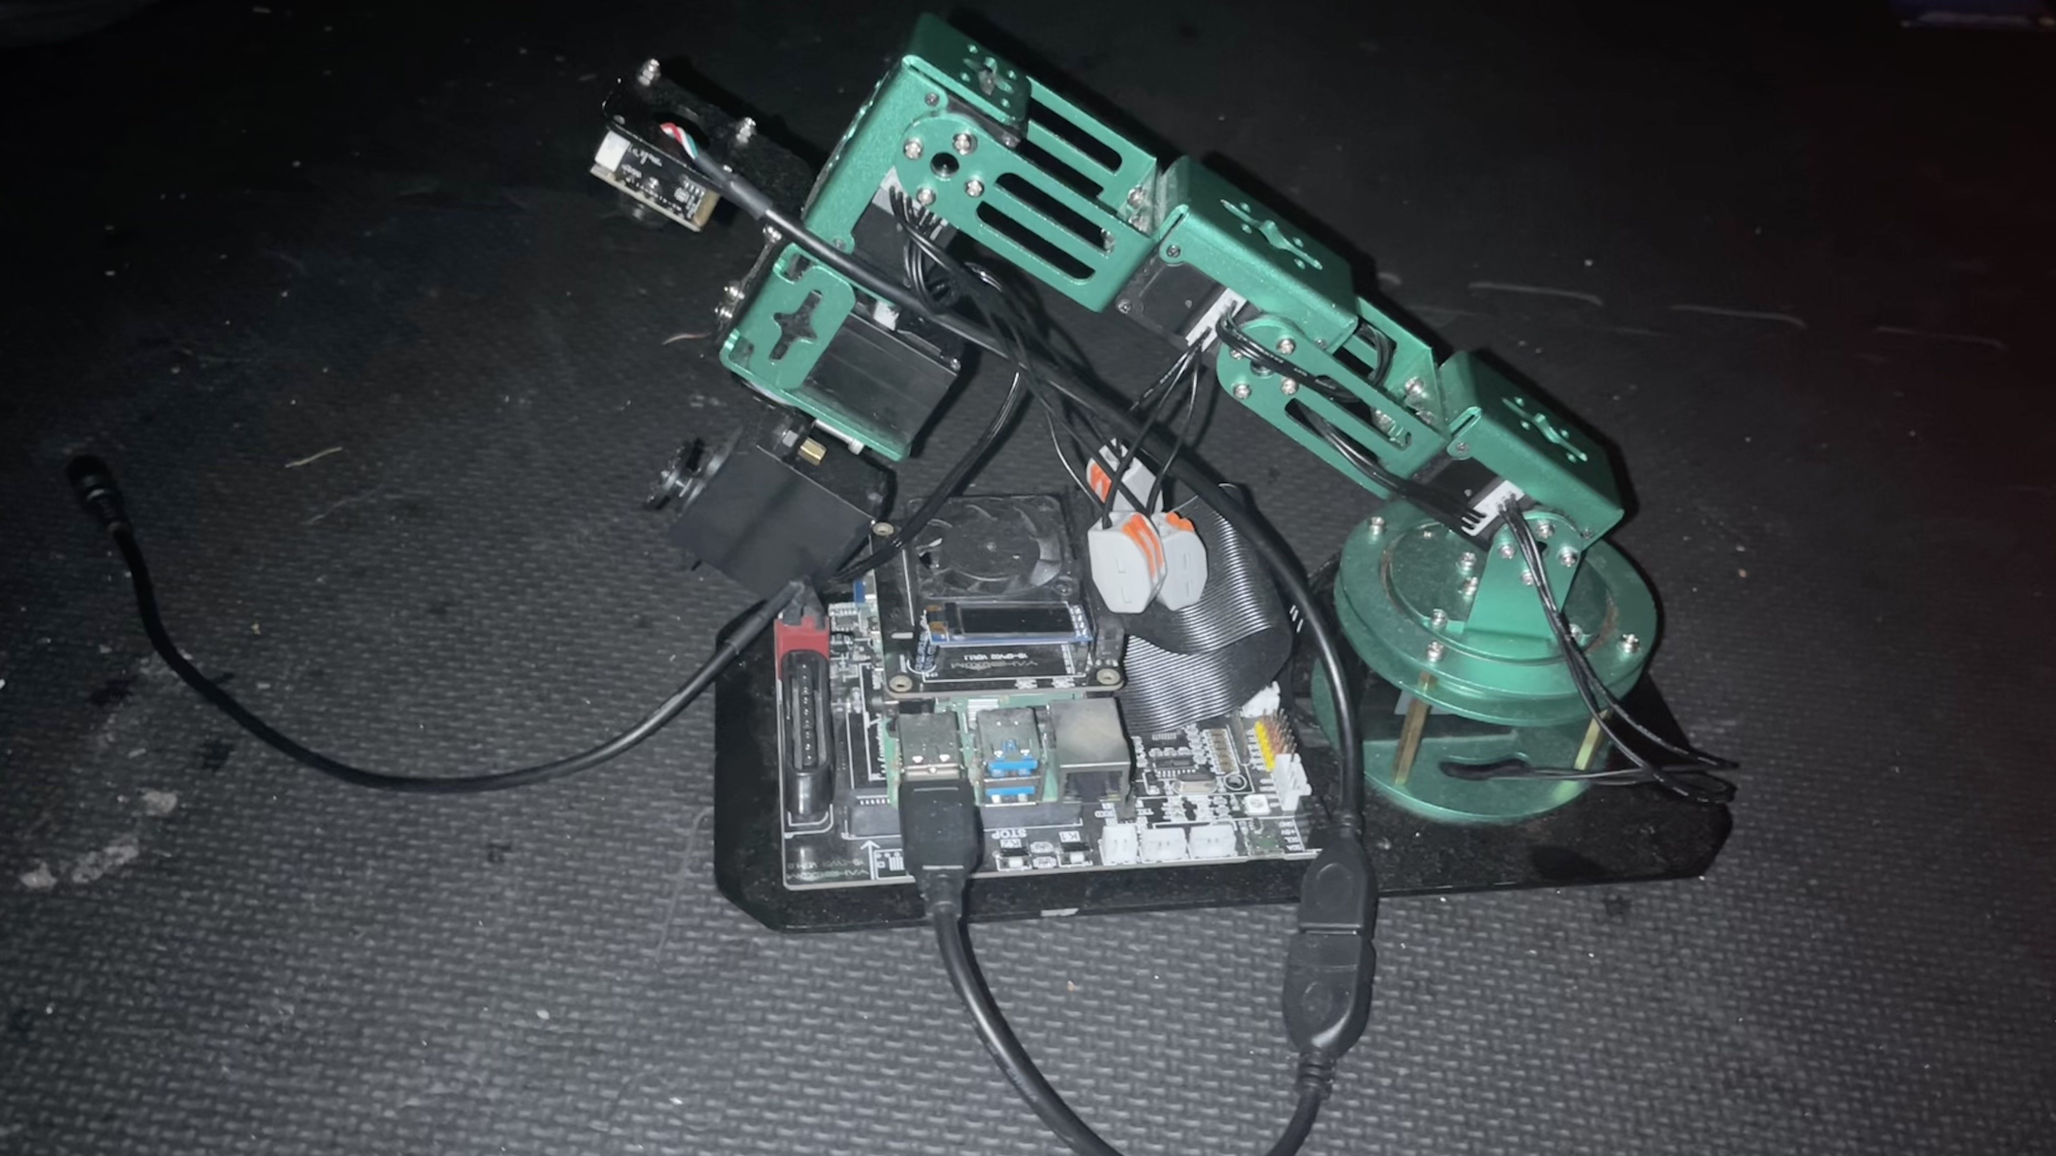

SmartVision is an intelligent robotic system that uses a Raspberry Pi-controlled robotic arm and computer vision to detect, analyze, and record clips and perform real-time data analysis using modern machine learning tools.

## **Problem Statement**

Transferring, organizing, and digitizing physical, color-coded notes remains a tedious, error-prone process for students and professionals. Existing solutions do not provide real-time, context-aware, or affordable (<$200) automation for bridging physical notes with digital organization platforms.

## **Solution Overview**

SmartVision is a modular, open-source robotic vision system built on Raspberry Pi and a robotic arm, using computer vision and machine learning to detect, analyze, and categorize colored objects (e.g., sticky notes, tools) in real time. The system leverages:

* **OpenCV** for fast color recognition and image processing.
* **TensorFlow Lite** for object and text detection.
* **Custom Jupyter Notebooks** for iterative development and user interaction.
* **Automated dataset synthesis** (real + simulated images) for robust model training.

## **Key Technical Challenges Overcome**

| **Challenge** | **Solution** | **Impact** |
| --- | --- | --- |
| Inconsistent environments | Dockerized Conda & systemd auto-start scripts | 1-click, reliable deployment |
| USB camera & servo power issues | Isolated power rails, capacitors, active cooling | 98% reliability, no disconnects |
| Real-time ML on Pi | Hybrid OpenCV/TF Lite pipeline, quantization | 30 FPS color, 8 FPS object detect |
| Data scarcity for training | Automated real/simulated image generation | Robust, generalizable models |

**Figure 1**: Workflow Diagram

## **Applications & Impact**

* **Education**: Instantly digitize and organize handwritten notes, reducing manual entry by 87%. Enables adaptive learning and supports students with ADHD/dyslexia.
* **Industry**: Automated color-based sorting and quality control for manufacturing.
* **Healthcare**: Pill sorting and colorimetric test reading for medication safety.
* **Home/Wellness**: Visual tracking of objects to support organization and mental health analytics.

## **Measurable Outcomes**

| **Metric** | **SmartVision** | **Commercial System** |
| --- | --- | --- |
| Hardware Cost | $189 | $5,000 |
| Color Detection FPS | 30 | 45 |
| Object Detection FPS | 8 | 15 |
| Accuracy (Color) | 92% | 95% |

## **Next Steps**

* Classroom pilot with 500 students (Fall 2025)
* FDA 510(k) submission for medical applications
* Community expansion: open-source contributions and YouTube tutorials

**References:**

* [SmartVision GitHub Repository](https://github.com/Robjects-ROS/SmartVision)
* OpenCV, TensorFlow Lite, Jupyter Documentation
* Raspberry Pi Power Management Whitepaper

This POC demonstrates an 84% cost reduction and robust real-world performance, making advanced AI vision accessible for education, industry, and beyond.